Solution
- .
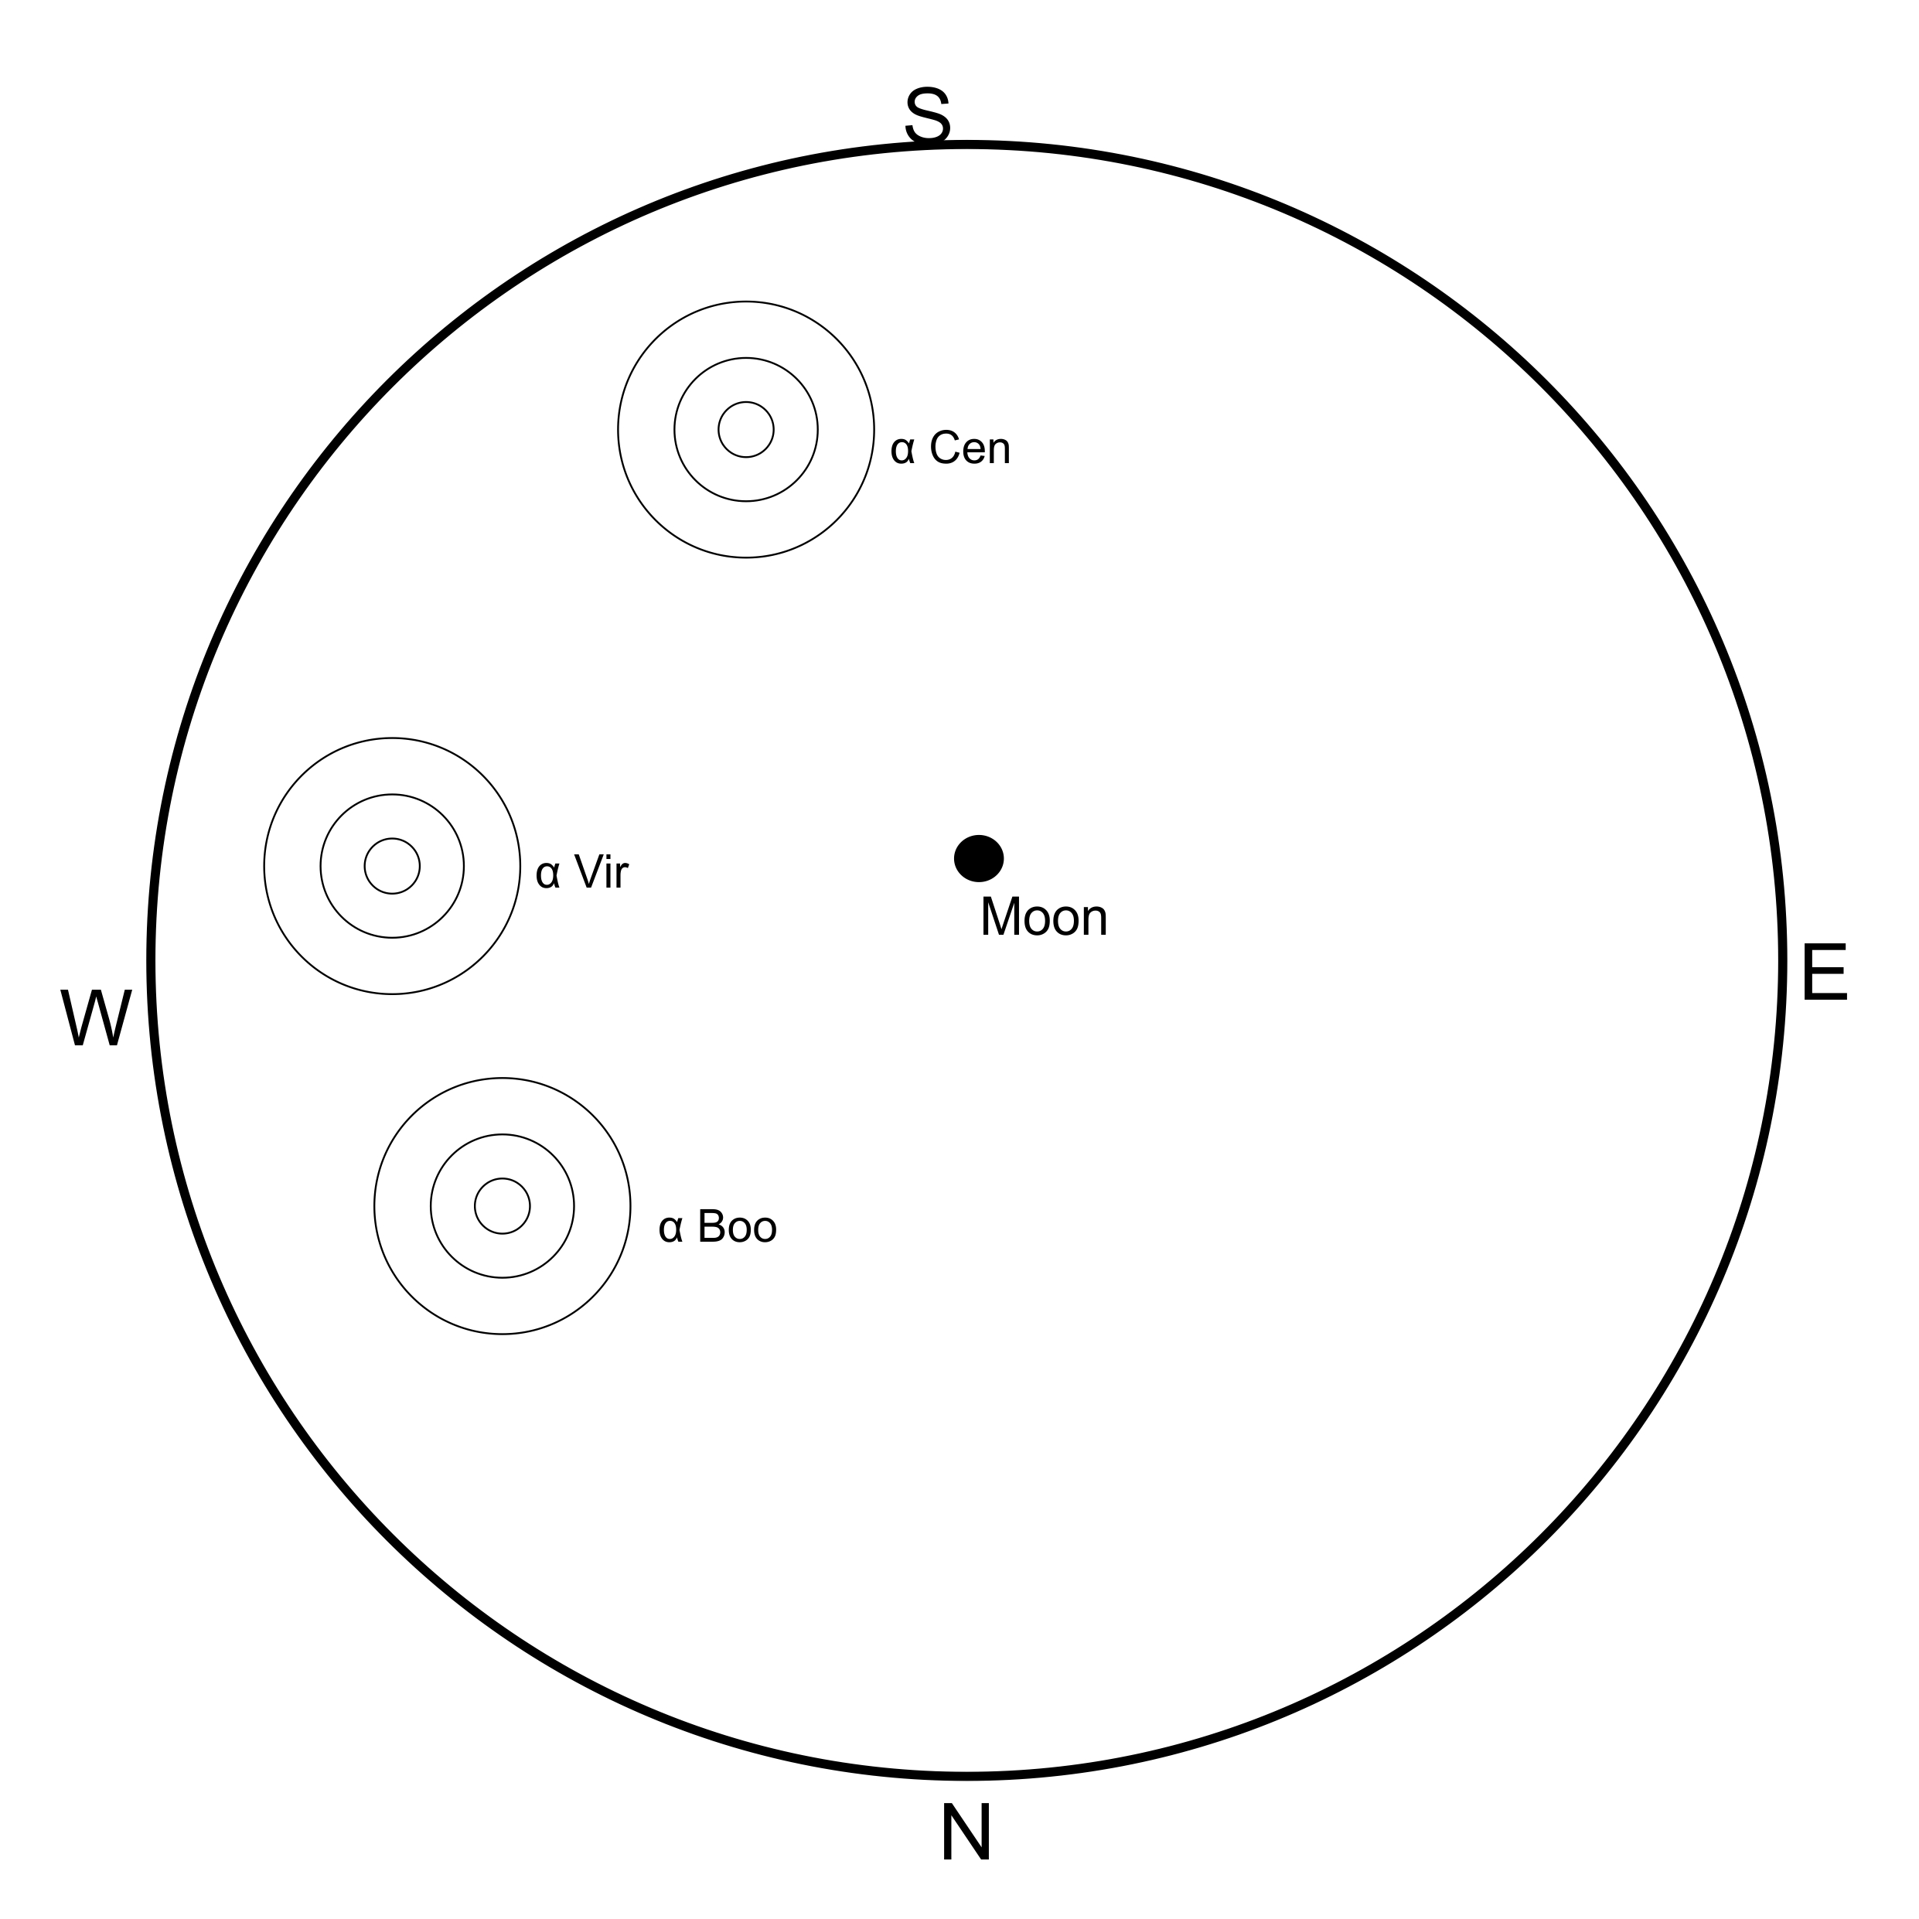

- .
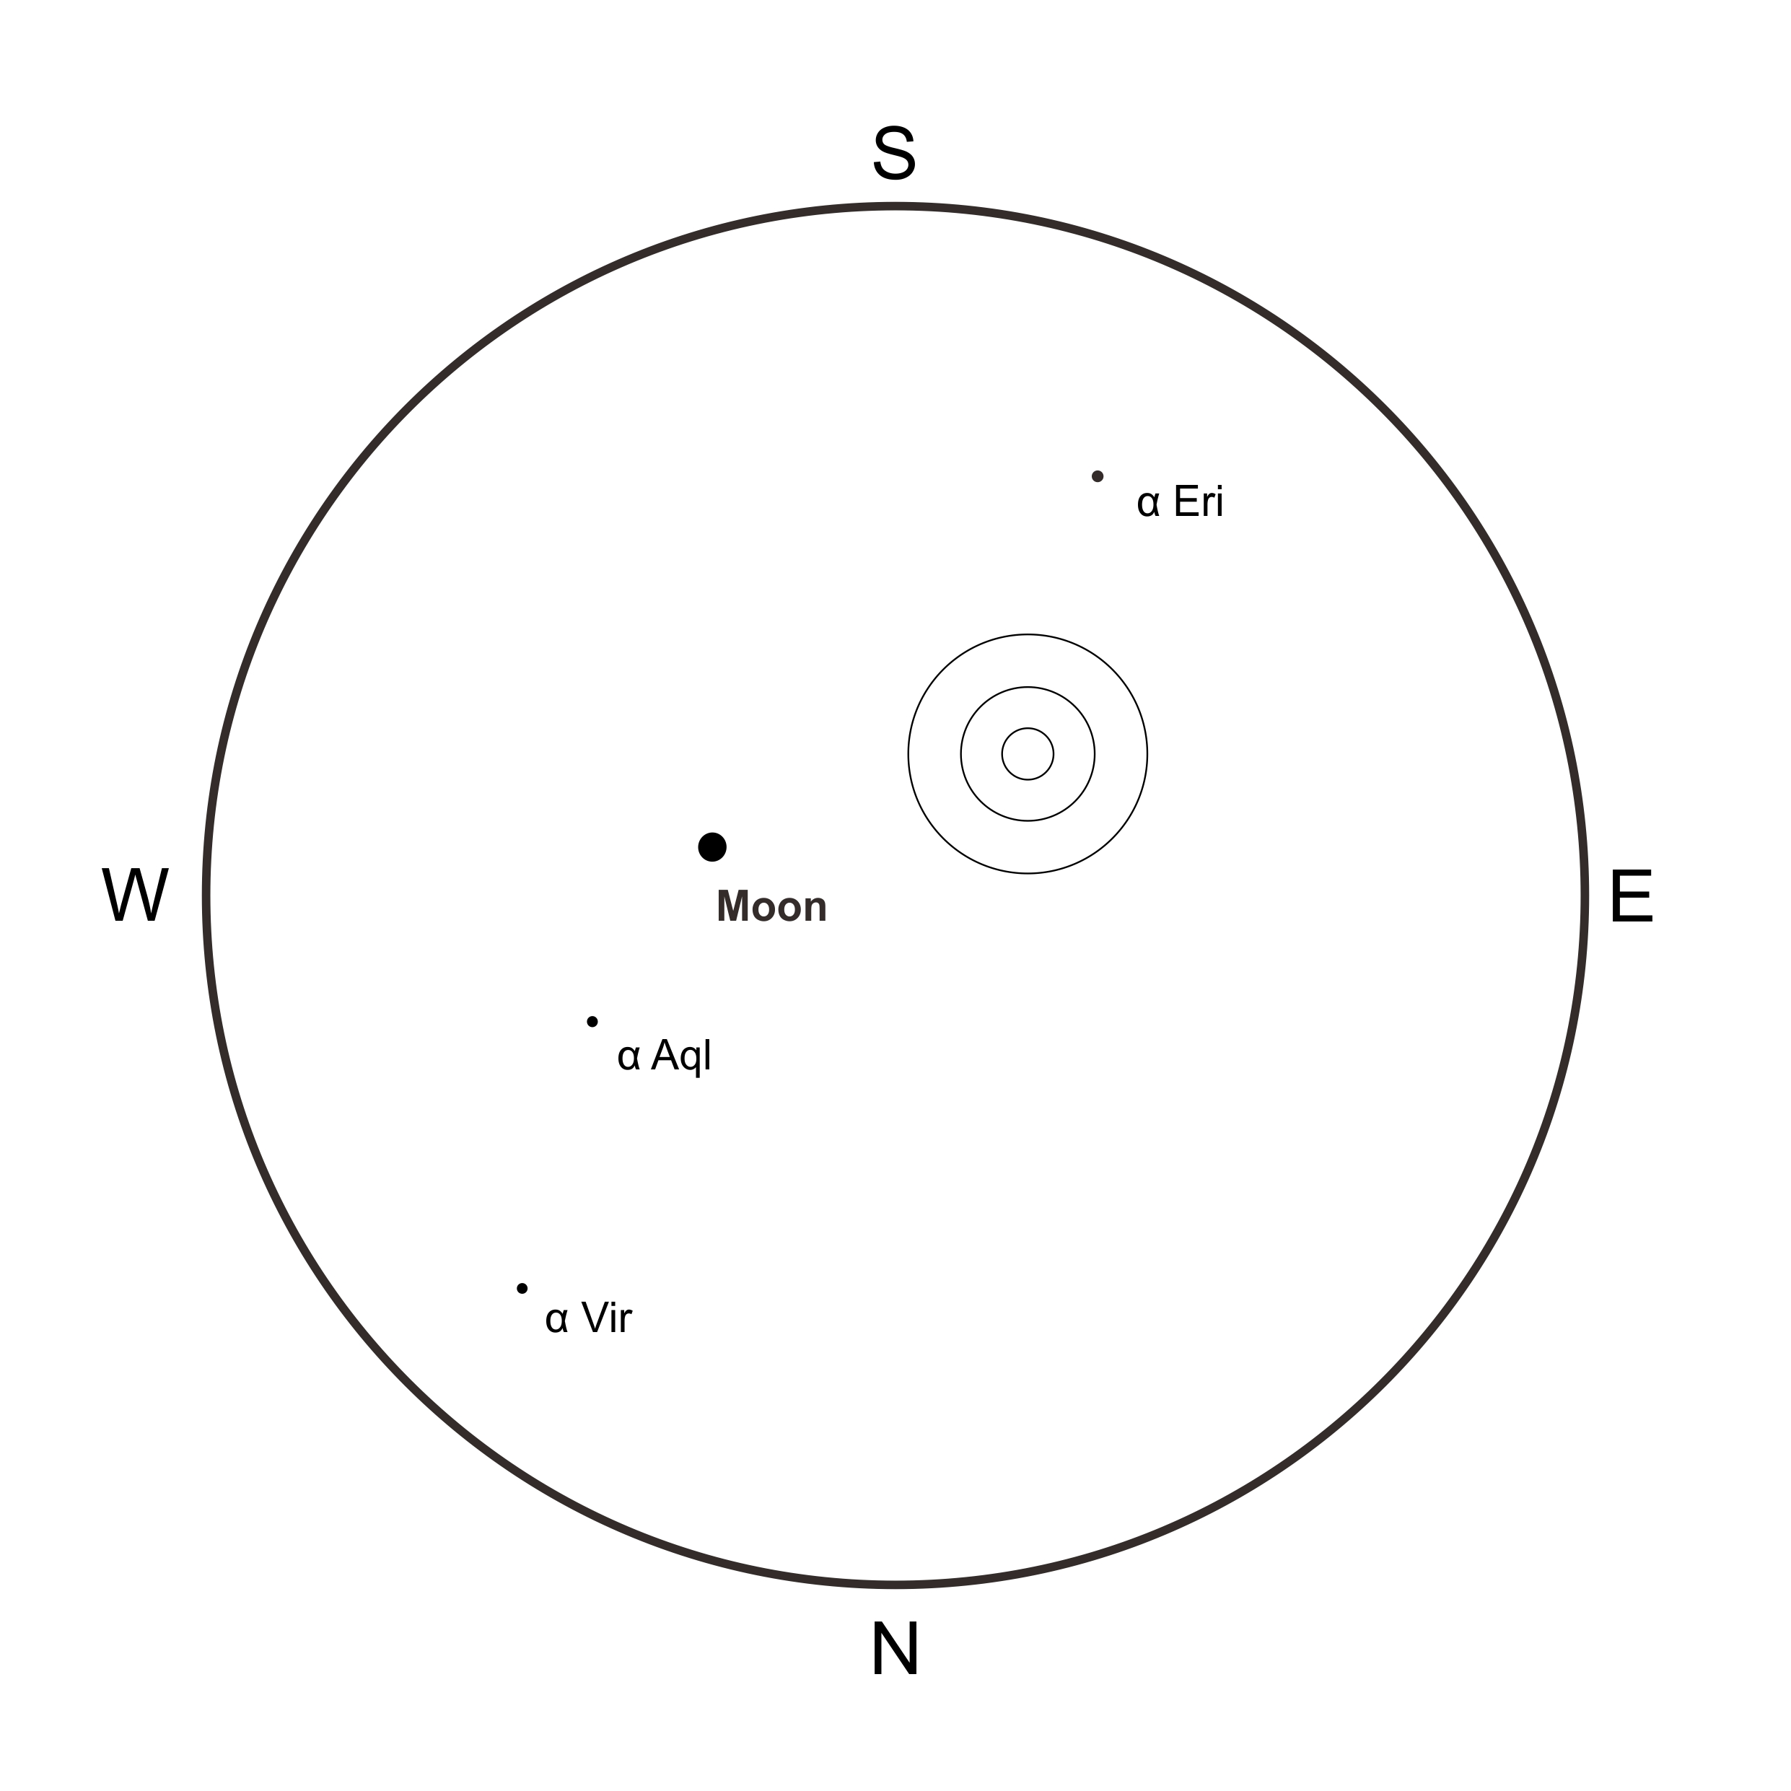
- Canopus
Rise Time | 16 : 33 : 57
Set Time | 05 : 51: 10

Full Mark : + 20 minutes
Half Mark : + 40 minutes

Quarter Mark : + 60 minutes

